Root Cause Analysis Report
Project: Evolon Dynamics Manufacturing – Invoice-to-Pay Process Optimization
Role: SAP Business Analyst (Accounts Payable Focus)
Date: April 2026

1. Executive Summary
Evolon Dynamics Manufacturing is experiencing significant delays in its Invoice-to-Pay (I2P) process due to missing or incorrect Goods Receipt (GR) entries. These delays disrupt invoice processing, increase manual workload, and negatively impact supplier relationships and financial performance.
This report analyzes process simulation data, identifies the root cause of the GR bottleneck using structured and AI-assisted analysis, and proposes a combination of process improvements and automation strategies to optimize performance.

2. Problem Statement
The invoice processing cycle is frequently delayed because Goods Receipts (GR) are either missing, delayed, or incorrectly recorded. As a result, the three-way match (Purchase Order – GR – Invoice) fails, preventing timely invoice approval and payment.

3. Business Impact

3.1 Operational Impact
- Increased invoice processing cycle time
- High volume of blocked invoices
- Increased dependency on manual intervention

3.2 Financial Impact
- Delayed supplier payments
- Loss of early payment discounts
- Inefficient cash flow management

3.3 Supplier Impact
- Reduced supplier trust
- Increased disputes and escalations

4. Step 1 – Simulation Data Analysis

4.1 Process Flow Observations
- The GR step is a mandatory prerequisite for invoice processing
- Missing GRs create process loops and manual rework
- Sequential dependency between Quality Inspection → GR → Invoice causes delays

4.2 KPI Analysis
KPI | Observation | Interpretation
GR Creation Time | High and inconsistent | Primary bottleneck
Invoice Processing Time | Delayed | Dependent on GR
Blocked Invoices (%) | High | Caused by missing GR
First-Time Match Rate | Low | Data inconsistency
Manual Interventions | Frequent | Lack of automation

4.3 Error & Exception Analysis
- Missing GRs are concentrated in specific warehouse locations
- Higher error rates observed in manually recorded GR entries
- Delays frequently occur after quality inspection
- Peak-time operations increase error probability

4.4 Key Patterns Identified
- GR delays directly lead to invoice blocking
- Manual processes increase variability and error rates
- Quality inspection acts as a secondary bottleneck
- Lack of visibility causes delays to propagate across departments

4.5 BPMN Process Model
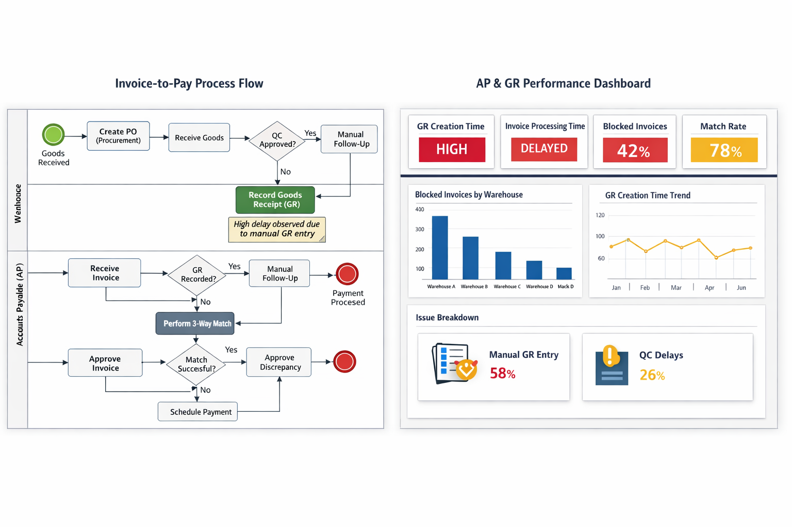
- The BPMN diagram visualizes the end-to-end Invoice-to-Pay process and highlights the Goods Receipt (GR) step as the primary bottleneck.

The model shows that when GR is not recorded, the process loops back to manual follow-up, causing delays in invoice processing and increasing operational inefficiency.

This confirms the findings from the simulation data analysis.

- The KPI dashboard provides a visual representation of process performance and highlights key inefficiencies.

The data confirms that delays in GR creation are the primary driver of invoice processing delays. High levels of blocked invoices and low match rates further indicate process instability.

These insights support the need for process standardization and automation.

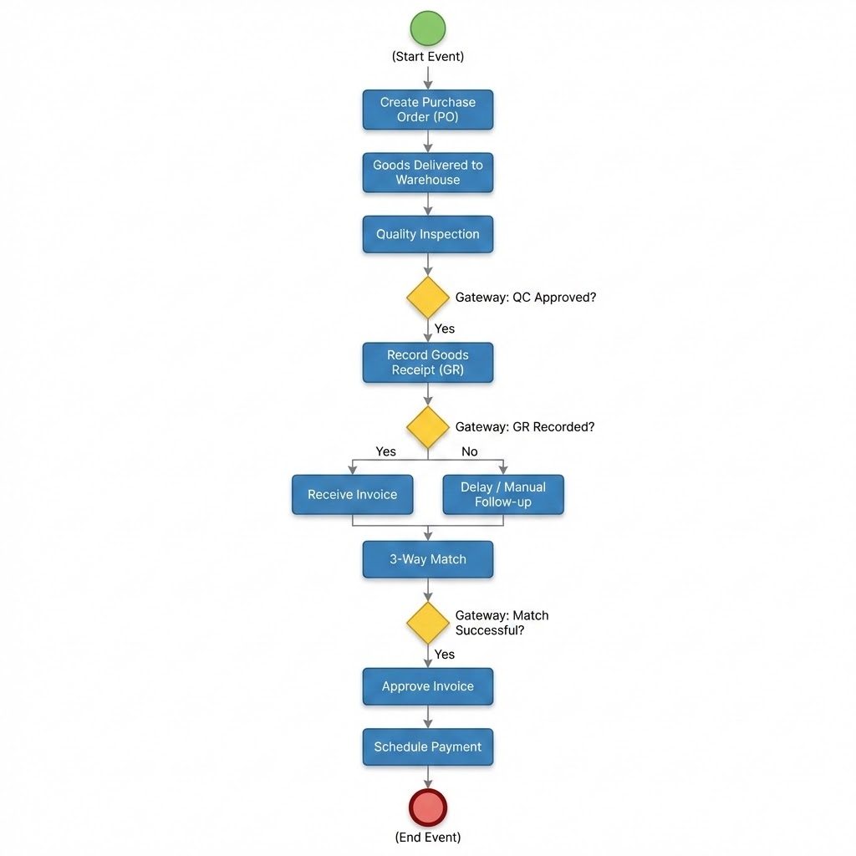
In addition to the visual BPMN diagram, a structured process flow representation is provided above using a diagrammatic format.

This representation reinforces the process logic and clearly illustrates decision points such as quality approval, GR recording, and invoice matching.

The model confirms that the Goods Receipt (GR) step is a critical control point. When GR is not recorded, the process diverts into a manual follow-up loop, creating delays and inefficiencies in the invoice-to-pay cycle.

5. Step 2 – Actors and Goals
Actor | Objective
Warehouse Team | Record accurate and timely GR
Accounts Payable (AP) | Process invoices efficiently
Suppliers | Receive timely payments
Procurement | Ensure accurate PO creation
ERP System (SAP) | Maintain data integrity and enable automation

6. Step 3 – Preconditions and Postconditions

6.1 Preconditions
- Approved Purchase Order (PO) exists
- Goods are delivered to warehouse
- Quality inspection process is initiated
- Supplier invoice is received
- GR is required as per company policy
- Process simulation data is available

6.2 Postconditions
- GR is accurately recorded in the ERP system
- Invoice is successfully matched and approved
- Payment is scheduled without delay
- Full audit trail is maintained
- Root cause is identified and resolved

6.3 Critical Success Factor
- Timely and accurate Goods Receipt (GR) entry
Without GR:
- Three-way matching fails
- Invoice processing is blocked
- Payment cannot proceed

7. Step 4 – Root Cause Analysis (AI-Assisted)

7.1 Manual Process Weaknesses
- Lack of standardized GR procedures
- Dependency on individual employees
- Delayed or missed entries
- Use of offline or paper-based tracking

7.2 Communication Gaps
- Limited coordination between Warehouse and AP
- No real-time visibility of GR status
- Lack of structured escalation process

7.3 ERP System Underutilization
- SAP system not fully leveraged for automation
- Missing alert/notification mechanisms
- Weak integration with warehouse operations

7.4 Quality Inspection Dependency
- GR creation depends on QC completion
- No parallel processing capability
- QC delays propagate to finance processes

7.5 Training Deficiencies
- Insufficient SAP transaction knowledge
- Lack of awareness of process importance
- Inconsistent execution across users

8. Root Cause Identification

Primary Root Cause
- Unstandardized, semi-manual GR process combined with underutilization of ERP system capabilities

Supporting Causes
- Lack of process standardization
- Insufficient training
- Weak interdepartmental communication
- Limited automation and system integration

9. Step 5 – Solution Development

9.1 Process Standardization
- Implement standardized GR procedures (SOP)
- Introduce GR checklists
- Assign clear ownership
Impact: Reduces variability and errors
Feasibility: High
Cost: Low

9.2 Automation Solutions
- Barcode/RFID-based GR entry
- Automated SAP alerts for missing GR
- Integration between QC and GR processes
Impact: High
Feasibility: Medium
Cost: Medium

9.3 Training Programs
- SAP GR transaction training
- Process awareness workshops
Impact: Medium
Feasibility: High
Cost: Low

9.4 Policy Enhancements
- Define GR entry SLA (e.g., within 24 hours)
- Monitor KPIs regularly
- Introduce compliance tracking
Impact: Improves accountability
Feasibility: High

10. Recommended Strategy
A phased hybrid approach is recommended:

Short-Term (0–3 Months)
- Implement SOPs
- Conduct training
- Introduce KPI monitoring

Mid-Term (3–6 Months)
- Implement barcode/RFID solutions
- Activate SAP alert mechanisms

Long-Term (6+ Months)
- Full process automation
- Integrate QC and GR workflows
- Enable real-time process monitoring

11. KPI Dashboard

11.1 Core KPIs
KPI | Current State | Target
GR Creation Time | High | < 24 hours
Invoice Processing Time | Delayed | -30%
Blocked Invoices (%) | High | < 5%
First-Time Match Rate | Low | > 95%

11.2 Operational KPIs
- GR Delay Rate
- QC Processing Time
- AP Processing Cycle Time
- Exception Rate

11.3 Root Cause Indicators
- High manual GR entry ratio
- GR delays by warehouse
- QC delay spikes
- Peak-time error concentration

11.4 KPI Insight
The KPI analysis confirms that delays in GR creation are the primary driver of inefficiencies in the invoice-to-pay process.

12. BPMN Process Model (Description)
The process model represents the end-to-end Invoice-to-Pay workflow, emphasizing the Goods Receipt (GR) step as the critical bottleneck.

Key Flow
- Goods are received
- Quality inspection is performed
- GR is recorded
- Invoice is received
- Three-way match is executed
- Invoice is approved and payment scheduled

Critical Bottleneck
If GR is not recorded:
- Invoice processing is blocked
- Manual follow-up is required
- Process loops are created

Process Weakness
- Sequential dependency between QC → GR → Invoice
- Lack of automation triggers
- Heavy reliance on manual actions

Optimization Opportunities
- Parallel processing (QC & GR preparation)
- Automated GR creation triggers
- Real-time monitoring dashboards

13. Next Steps
- Implement pilot in a selected warehouse
- Monitor KPIs for 3 months:
  - GR creation time
  - Blocked invoices
  - Invoice cycle time
- Evaluate results and scale solution
- Establish continuous improvement cycle

14. Conclusion
The root cause of delays in the Invoice-to-Pay process is not primarily technical or supplier-related, but stems from process inefficiencies, lack of standardization, and insufficient use of ERP capabilities.
By implementing structured process improvements, enhancing training, and leveraging automation, Evolon Dynamics Manufacturing can significantly improve operational efficiency, reduce delays, and strengthen supplier relationships.

Author : Tuncay Şahin

